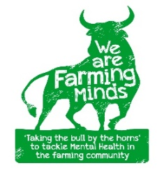
We Are Farming Minds Email: wearefarmingminds@gmail.com
Kings Pitts Farm Web: www.wearefarmingminds.co.uk
Kingsthorne
Hereford HR2 8AQ Registered Charity: 1191461

Counselling Referral Form

Date: | Referral completed by:

- Name
- Contact number
- Age

- Email address
- Brief outline of reason for referral / counselling issue(s) to be explored

- What is your connection to the farming community in Herefordshire?

- Once we have found a suitable counsellor, are you happy for us to share your contact details so the counsellor can get in touch with to arrange the first session?

- How/when would you prefer the counsellor to contact you?

- Where are you based? And how far are you willing/able to travel to sessions?

- Are you flexible with times or are there set times/days that you would be able to attend sessions?

- Male/female preference for counsellor?
- Next of kin info (first name and number only)
- Consent given to use information? |  | Consent for message to be left on answer machine?
If you are completing this form on behalf of someone else, please confirm they have given consent for this information to be shared

YES / NO

Once we have found a suitable counsellor, based on your answers, we will forward your details to them, and they will contact you to arrange your first session. You can then arrange all following sessions directly with the counsellor and they will simply invoice us, so you do not need to deal with any paperwork or invoices.

Please note that most counsellors have a cancellation policy that varies from 24 – 48 hours. Cancelled appointments may still be chargeable if sufficient notice is not given or failure to turn up. Please check this policy with the counsellor when they contact you.

